Install Raspbian into Raspberry Pi

Tools:

1. 7zip

I recommended 7zip because when I try to extract using 7zip it cause less trouble. But if you want to use another extraction tool fell free to choose

1. Raspbian (<https://www.raspberrypi.org/downloads/raspbian/>)

Choose the image file according to your flavor

1. SDFormater

To format the file inside the micro SD

1. Win32diskimager

To install the image file into the micro SD

Steps of Procedure:

* Extract the image file of the raspberry pi to the folder that you wish to put

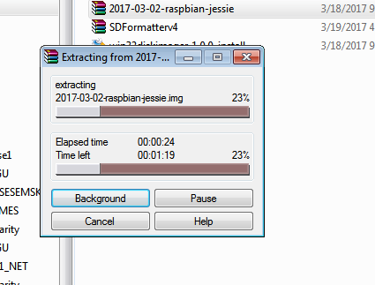

(figure 1-1)

* Place the micro SD to the adapter and plug into your windows machine. Make sure the lock in the left side is slit up to turn off the write protected. After the micro SD is plug into the computer , format the disk using SD formatter

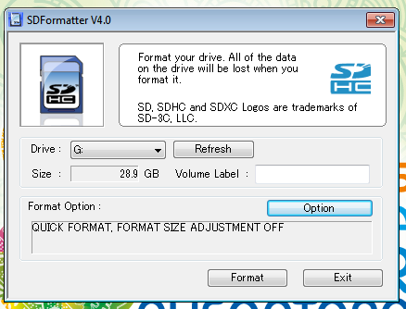

(figure 1-2)

* After the disk is clean and formatted you can start to install the raspbian into the Micro SD card using the win32 disk imager

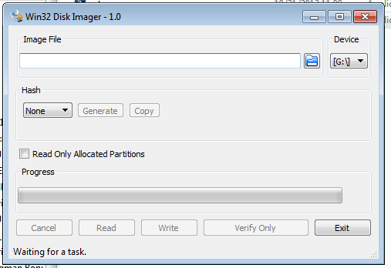

(figure 1-3)

* After the win32 disk image install raspbian it should follow like figure 1-4

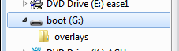

(figure 1-4)